BYTEWISE LIMITED

Data Engineering Track

Task: Week – 2 (First Month)

Task No: 1 & 2

Task Date: 20-03-2023

Internee Name: Umer Farooq

Mentor Name: Muhammad Ahtisham

# Task Details:

This task includes the following:

1. Installation of MSQL Server and SSMS
2. Downloading and Attaching Northwind Database in SSMS
3. Fork the [Repo](https://github.com/ahti-mughal/BWT_DE_Repository.git)
4. Clone it on Local Machine and PR

# Installation of MSQL Server & SSMS:

Follow the following Steps in order to successfully install the MSQL & SSMS:

* Click on this link, and install developer edition of MSQL:

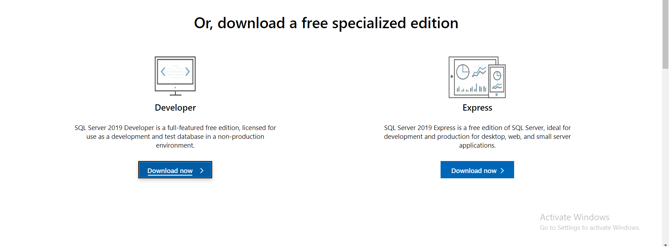

* Run the downloaded executable file to start the SQL Server installation wizard.
* On the "Installation" page, select "New SQL Server stand-alone installation or add features to an existing installation" and click "Next".
* On the "Product Key" page, enter your product key or select the evaluation edition option and click "Next".
* On the "License Terms" page, read the terms and conditions carefully, accept them, and click "Next".
* On the "Feature Selection" page, select "Basic" and click "Next". This will install the SQL Server Database Engine, SQL Server Replication, and SQL Server Management Tools (SSMS).
* On the "Instance Configuration" page, select "Default instance" and click "Next". You can also choose to create a named instance if you need multiple instances of SQL Server on the same machine.
* On the "Server Configuration" page, specify the service accounts and authentication mode for the SQL Server services, and click "Next".
* On the "Database Engine Configuration" page, configure the server authentication mode, specify the SQL Server administrators, and configure the data directories for the SQL Server instances. Click "Next" when you're done.
* On the "Ready to Install" page, review the installation settings and click "Install" to start the installation process.
* Once the installation is complete, you can launch SSMS by clicking the "SQL Server Management Studio" shortcut on the Start menu.

# Downloading & Attaching Northwind DB:

Click [here](https://businessimpactinc.com/blog/install-northwind-database/) to download the northwind database for MSQL.

* Extract the Northwind database files to a folder on your computer.
* Open SQL Server Management Studio (SSMS) and connect to your SQL Server instance.
* Right-click on the "Databases" folder and select "Attach...".
* In the "Attach Databases" window, click the "Add" button.
* Browse to the folder where you extracted the Northwind database files and select the "Northwind.mdf" file.
* Make sure the "Northwind_log.ldf" file is selected as well.
* Click the "OK" button to add the database to the list of databases to be attached.
* **If you encounter an error about file permissions,** you may need to grant the SQL Server service account permissions to the folder where the Northwind database files are stored. To do this, right-click on the folder, select "Properties", then navigate to the "Security" tab. Click the "Edit" button, then "Add" to add the SQL Server service account. Give it "Full Control" permissions, and click "OK".
* **If you encounter an error about the log file already existing**, you can delete the log file and reattach the database. To do this, navigate to the folder where the Northwind database files are stored, delete the "Northwind_log.ldf" file, and then repeat steps 4-8 to reattach the database.
* Once the Northwind database is attached, you can expand the "Databases" folder in SSMS to see the Northwind database listed. You can now query and work with the Northwind database like any other database in SQL Server.
* That's it! You should now have the Northwind database attached to your SQL Server instance and ready to use.

# Forking the Repo & Cloning and Creating Pull Request:

To fork a repository named "ahti-mughal/BWT_DE_Repository" and name it for your own convenience to "Bytewise_DE_Track" you can follow these steps:

1. Open your web browser and go to the repository "ahti-mughal/BWT_DE_Repository".
2. Click on the "Fork" button in the top right corner of the page.
3. Choose where to fork the repository: your own GitHub account, an organization you're a member of, or a personal account.
4. After forking the repository, it will be available in your GitHub account under the name "Bytewise_DE_Track".

To clone this repository using SSH on your local machine, follow these steps:

1. Open the terminal on your local machine.
2. Navigate to the directory where you want to clone the repository.
3. Type the following command: **git clone git@github.com:YOUR-GITHUB-USERNAME/Bytewise_DE_Track.git**. Replace YOUR-GITHUB-USERNAME with your own GitHub username.
4. Press enter and wait for the repository to be cloned on your local machine.

To add your own tasks folder in the cloned repository that you forked and also add files related to tasks that you performed and create a pull request, follow these steps:

1. Open the repository in a text editor or integrated development environment (IDE).
2. Create a new folder called "tasks" in the root directory of the repository.
3. Add your task files to the "tasks" folder.
4. Open the terminal and navigate to the cloned repository directory.
5. Type the following commands to stage and commit your changes:

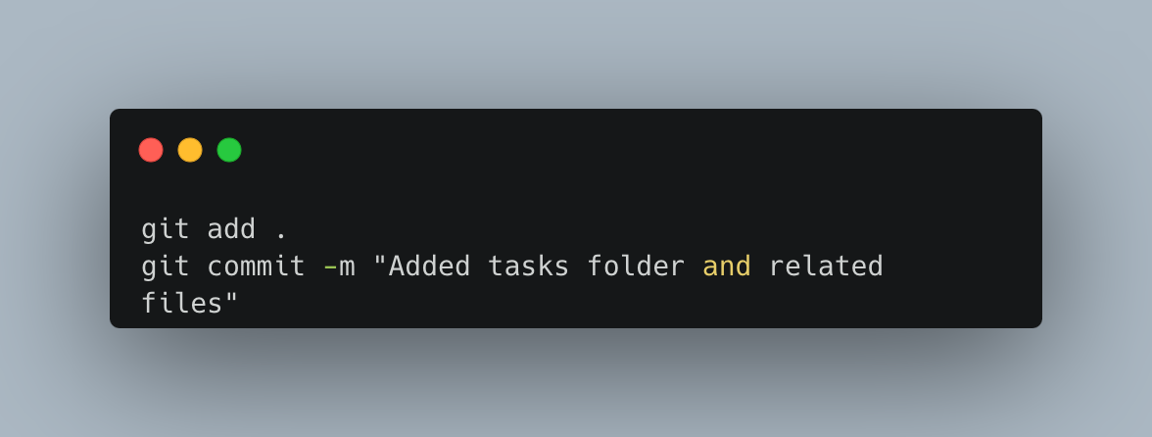

1. Push the changes to your forked repository by typing the following command: **git push origin main**.
2. Go to your GitHub account and open the forked repository "Bytewise_DE_Track".
3. Click on the "New pull request" button.
4. Select the base repository as "ahti-mughal/BWT_DE_Repository" and the base branch as "main".
5. Select your forked repository as the compare repository and branch.
6. Review the changes and click on the "Create pull request" button.
7. Wait for the owner of the base repository to review and merge your changes.